1
Practice Hand Hygiene
often throughout the day. Teach them to sing their ABCs or have them count for at least 20 seconds ensuring they wash front, back, & in-between their fingers.

2
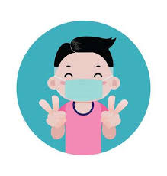
Practice Putting Mask On/Off. Your child will be required to wear a mask on the bus, upon entering school, & within the hallways. Teach them to not touch the inside of their mask when taking it off.

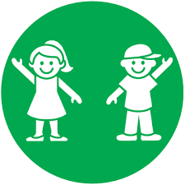
3
Practice 6ft of Distance. Measure the distance on the floor. Consider temporarily laying pieces of paper down for a visual.

4
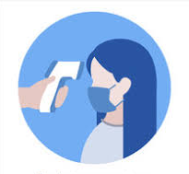
Purchase a Thermometer Check your child’s temperature every morning. If 100.4 or higher, they must stay home until fever free (without the use of Tylenol/Motrin). If they develop a fever at school, they will be required to remain out of school for 3 days.

5
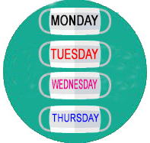
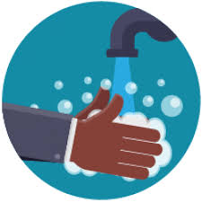
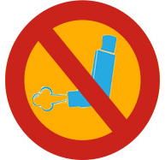
Make/Purchase Extra Masks. When possible, masks should only be used one time. Consider making or buying multiple masks to give you proper time to wash them between use.
10 things you can do to prepare
for returning back to school

6
Update Immunizations/Physical. Each are
required to enroll for the school year. Contact your child’s pediatrician for an appointment. Immunizations can also be obtained at the Health Dept.

7
Change Aerosolized Medication. Nebulizers &
inhalers without a chamber cannot be administered in school. Speak with your child’s pediatrician to obtain the proper equipment & to update the Asthma Action Plan.

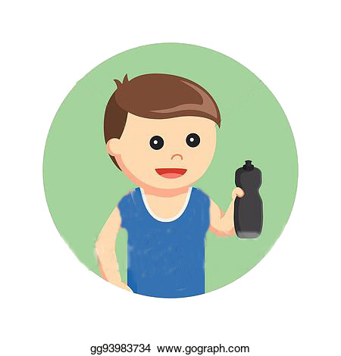
8
Purchase Reusable Water Bottle to be brought to school. Water fountains will not be in-service.

9
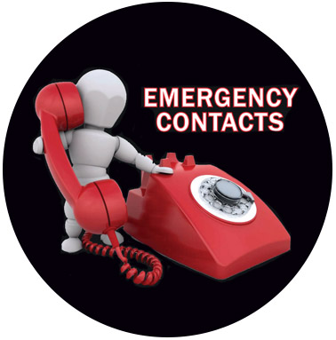
Verify/Update Emergency Contacts. If your child presents with COVID-like symptoms, they will be placed in an isolation room and will need to be picked up immediately. Please ensure a contact can be reached at any given time.

10
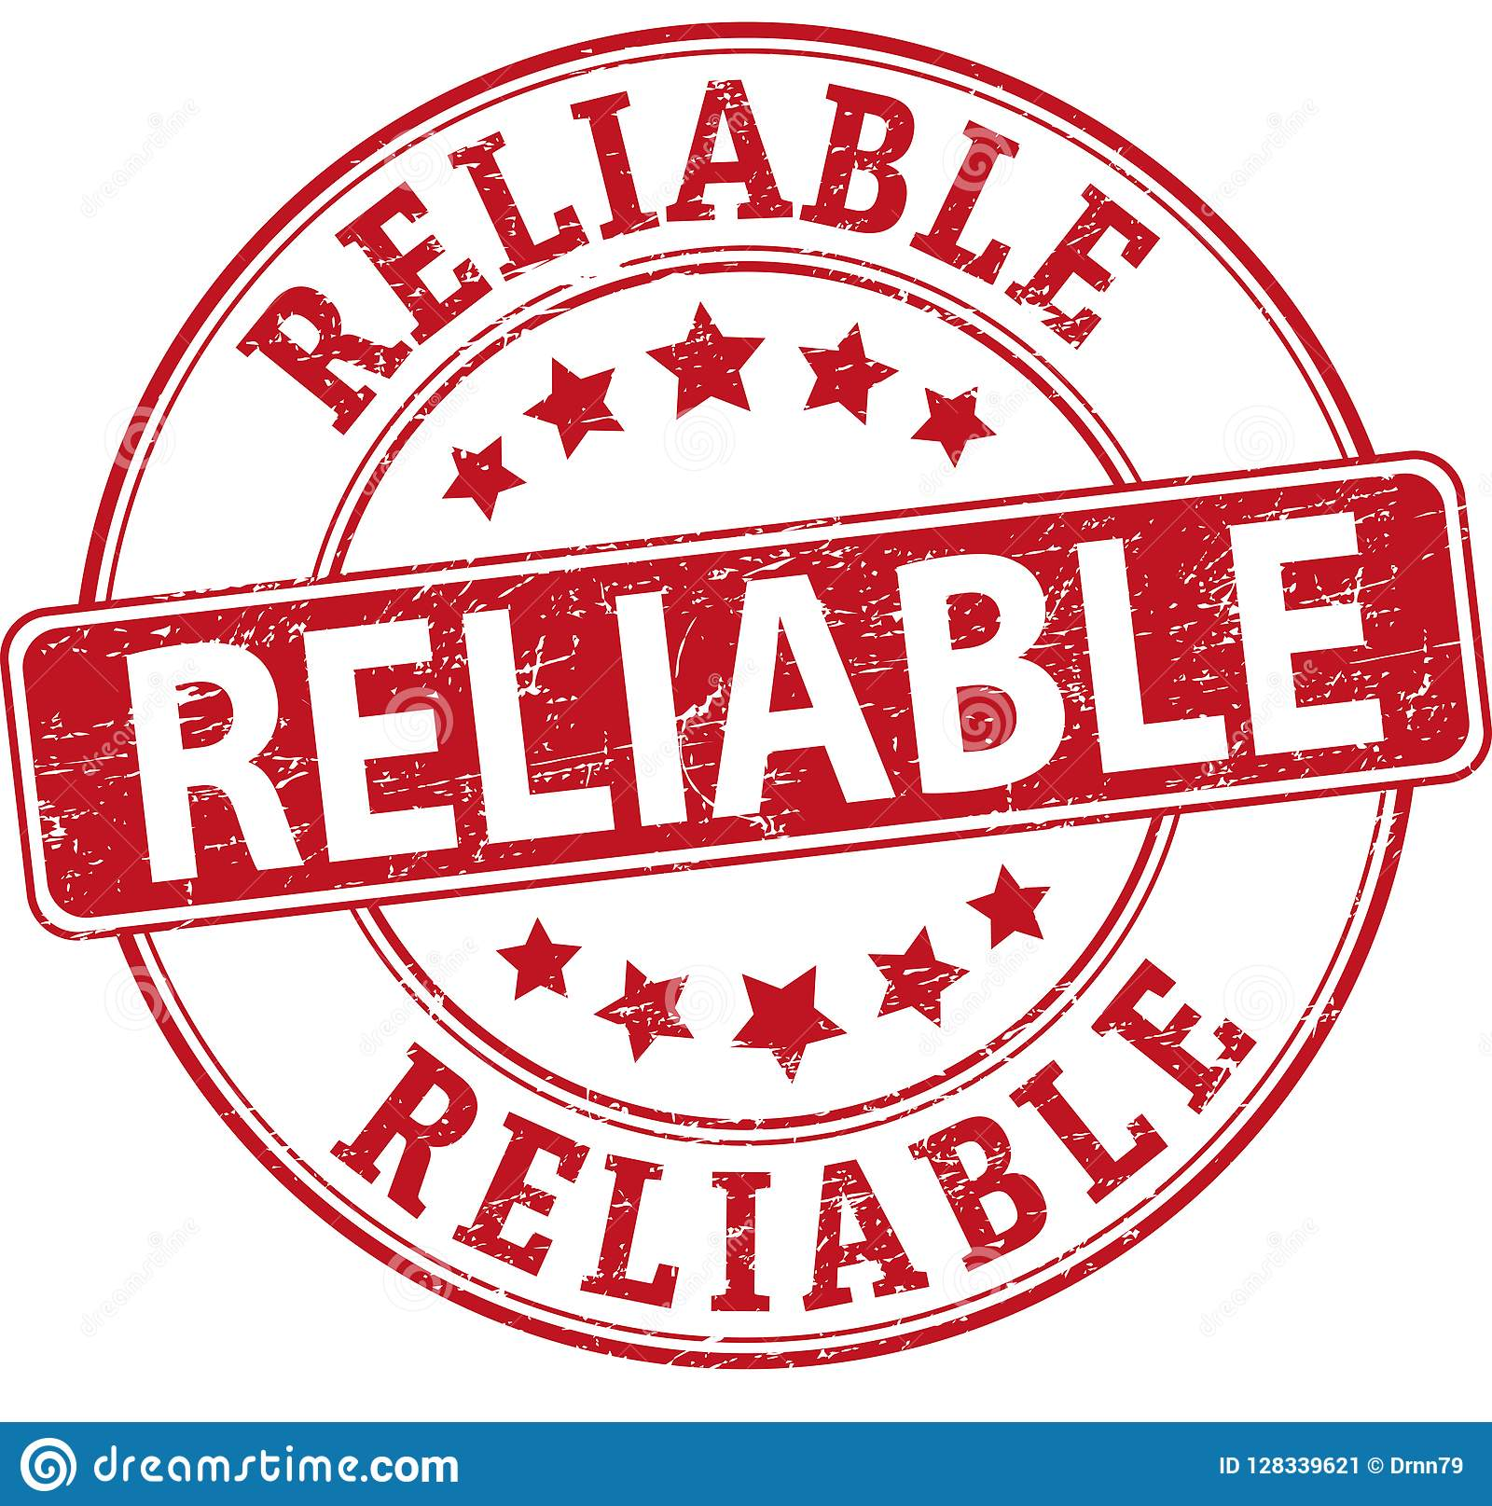
Stay Informed. Educate yourself from reliable sources such as the CDC, ________ Department of Health, and the ___________ Public School websites.

